(Approx. 652 words)

3 for a Quarter – Tips & Tricks
By Debra Carlson, Editor, CLC Computer Club
Tech Notes, Q3 2021
cvc.computer.club (at) gmail.com

Number 1 – Refurbs
Buying items refurbished seems like the perfect solution. Products labeled “refurbished” are fully functional but can’t technically be sold as “new” anymore for reasons vary by manufacturer. Because of this, they’re typically cheaper though “hundreds of dollars” in unlikely for a current model.

Refurbished can mean something different depending on the manufacturer. However, it usually means that a product was purchased by a customer and eventually returned while still under warranty because the buyer had an issue. The machine is “repaired” and resold. The amount of upgrade/repair differs by manufacturer.

Many people assume all of the following definitions, seen on outlet sites, are refurbished. They are not. Here is the list of terms to help --
- Shipping and/or exterior damage: Dents, scratches, or other surface damage.
- Open box: Purchased, used, then returned by a customer. They might show small signs of wear and cosmetic damage but are considered “refurbished” because they were examined and found to be in resale condition.
- Unopened/returned: A return that was never even opened.
- Demo models: Products used in stores, displayed at trade shows, or loaned to reviewers might be repackaged and eventually sold as refurbished items.
- Renewed models: Generally, preowned machines have been cleaned and, perhaps, loaded with a new operating system for resale.
- Check with your retailer and for the certifications and warranties offered on machines (note: some open box machines, e.g., only carry what is remaining on the original warranty. If this was a display machine, the warranty might be almost over by your time of purchase.). Retailers that don’t offer a return policy are best avoided since you have no guarantee that you’ll actually get your money’s worth or have support if something malfunctions. Refurbished items being sold “as-is” are a gamble, so you have to weigh your purchasing decisions carefully.
- Good refurb machines can be great for trips or students where there is a higher possibility of breakage. They can also be great for learning “deep dives” before spending money for a new computing adventure.
- Remember to check out the current supported technology level and look at the life expectancy for the device. For example, if it is a certified refurb, but the model will not support operating system upgrades after two years, the device has a 2-year life. Is it worth the price you are paying with this in mind?

Number 2 – Google Privacy Check (and others) myaccount.google.com/data-andpersonalization

Go to the link above when you are logged into your Google account, and you might be surprised at the number of options available for your customization.

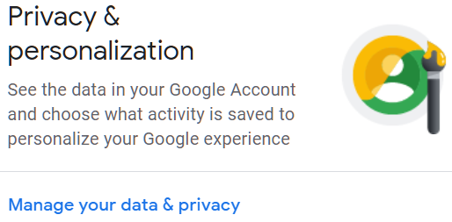
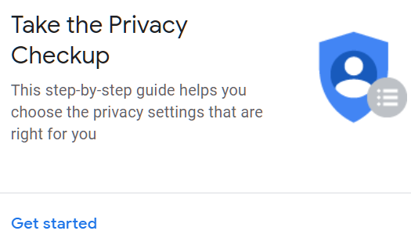

If you’ve never been through this area and you have a Google account, DO IT NOW. The Google home page will have taunted you to do it – you may have even gotten emails about it. DO IT.

The Privacy checkup will walk you through all the settings.
Not a Google customer? How about Facebook?
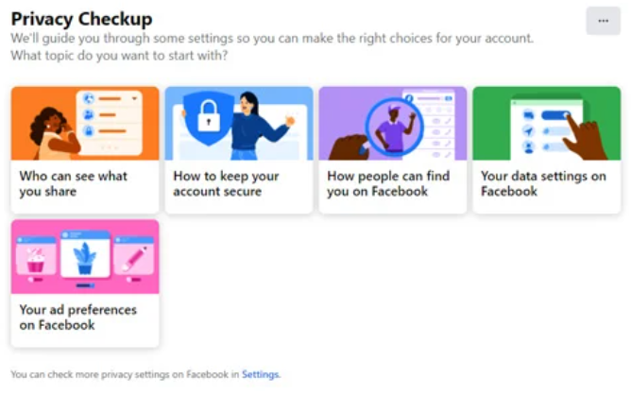

Most online platforms let you choose at least some of your information that others can see or search. Review this often. Your information should be yours to control.

Note: 2-factor authentication. If you read email in a “client” rather than from a web page, you may avoid getting to your email. It’s worth asking for help or guidance on this option.

Number 3 Zooming with a Mouse

If you have a mouse with a scroll wheel, holding down your CTRL key in Windows and most Windows-compliant apps will Zoom in or out (up for in, down for out). Great for viewing small print on one part of a page.

For Mac desktops, go to Accessibility in System Preferences, and click the box shown below.

Note: this will Zoom the currently viewed area of a page, so you will need to Zoom out to move to another area of the page.

